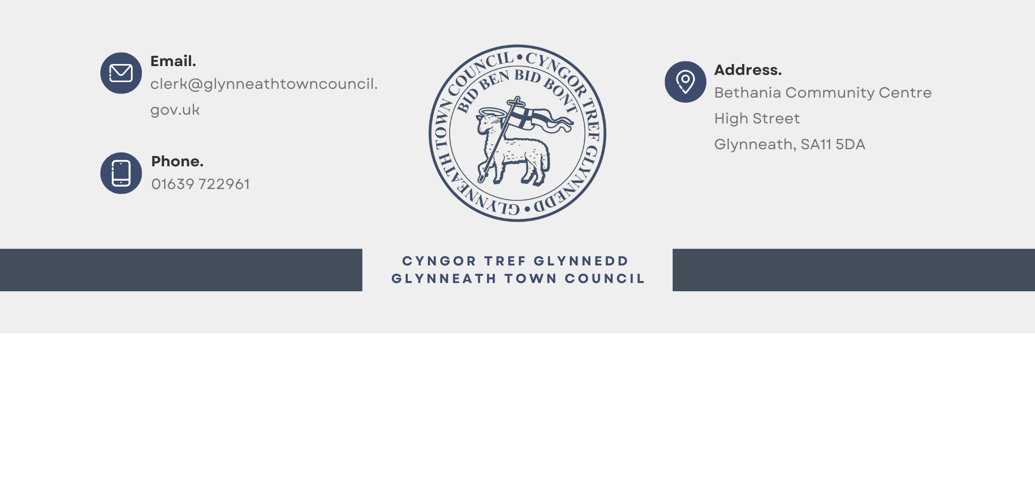

Invitation to Tender (ITT) for Refreshment Provision at Glynneath Miners’ Welfare Park

1. Introduction
Glynneath Town Council invites applications from mobile refreshment providers to operate at their brand new Glynneath Miners’ Welfare Park, Addoldy Road. This will run through the summer school holiday period from 28th of July to the 5th of September 2025.
We seek high-quality, family-friendly food and drinks that complement the park’s use and enhance the visitor experience.

2. Scope of the Opportunity
- A catering pitch is available for trading during peak hours (10 am to 6 pm daily).
- A variety of offerings is sought, including hot/cold drinks, ice cream, light meals, and snacks.
- The Council may license more than one trader, but not two of the same type (e.g. not two coffee vendors).
- All traders must be self-sufficient as access to utilities may be limited.
- Traders must leave no trace and ensure waste is managed responsibly.
- Traders must hold or arrange their own Street Trading license through NPTCBC. Glynneath Town Council will provide written permission as the landowner.

3. Duration and Fees
- The license to trade will run from the 28th of July to the 5th of September 2025 inclusive, where you may be allocated days to trade on rotation.
- The hours permitted are between 10 am and 6 pm daily.
- The pitch fee is set at £40 per day.
The Council reserves the right to negotiate final terms with the successful applicant(s).

4. Application Requirements
Applicants must submit the following:
- Business/trader name and contact details
- Description of proposed food/drink offer
- Menu and sample pricing
- Photos of unit/vehicle and equipment
- Evidence of public liability insurance (£5 million minimum)
- Food hygiene certificate and registration with relevant authority
- Gas/electrical safety certificates (if applicable)
- Waste disposal plan
- Optional: Sustainability measures and community benefits

5. Evaluation Criteria
Criteria | Weighting
Quality and suitability of offer | 40%
Experience and presentation | 25%
Compliance with legal requirements | 20%
Sustainability / local benefit | 15%
Glynneath Town Council is not bound to accept the lowest, the most economically advantageous, or any tender submitted.

6. Deadline and Submission Instructions
The deadline for submission is 12:00 noon on Friday, 11th of July 2025.
Applications should be submitted via email to clerk@glynneathtowncouncil.gov.uk or by post to:
The Clerk
Glynneath Town Council
Bethania Community Centre, High Street, Glynneath, SA11 5DA.
Late applications will not be considered.

7. Terms and Conditions

- Glynneath Town Council does not guarantee to keep any part of any tender confidential if its disclosure is requested under the Freedom of Information Act 2000.
- No payment will be made for work involved in preparing or submitting tenders.
- This opportunity is a license to trade, not a lease or tenancy.
- Traders must comply with all relevant legislation and public health guidance.
- The Council reserves the right to withdraw or terminate the licence for breach of conditions.
- Successful applicants must provide evidence of appropriate insurance and certifications, risk assessments, and normal operating procedures.
- Applicants must ensure they are able to comply with the accompanying licensing agreement.
- Successful applicants much clearly display their tariff of charges to the public.
- Vehicles must only use the access point to the park of Addoldy Road.
- Successful applicants must supply the Clerk with full contact details including an out of hours contact telephone number.
- Pitch fees are to be paid either in advance by BACS or cash or on the day by cash.
- Applicants should fill in all applicable sections in the following forms:

Schedule 1: Insurance

Public Liability Insurance

- Minimum indemnity level: £5m
- Please attach a copy of your Public Liability insurance policy.

Question | Response
Name of insurer
Policy number
Extent of cover | £
Expiry date

Motor Insurance

- Please attach a copy of your Motor Insurance policy.

Question | Response
Name of insurer
Policy number
Extent of cover | £
Expiry date

Schedule 2: Method Statements

Q1, Please describe in detail what the Product it is that you will be offering and what your preferred trading pattern would be (i.e. daily, once per week, twice per week etc).
Responses should be limited to 500 words.

Q2, How many days of the week would you prefer to operate from the pitch? Please note these days and times will form your contract (Responses should be limited to 500 words)

Q3, It is vitally important that all pitches and surrounding area must be kept clean and tidy, how will you ensure that you keep impact to the environment to a minimum? (Responses should be limited to 500 words).
Q4, The Miners’ Welfare Park can be a busy site, how will you ensure the safety of park users while you are operating, entering, or exiting the site? (Responses should be limited to 500 words).

Schedule 3: Declaration & Safeguarding

I warrant that I have all the requisite authority to sign this Tender.
Name
For and on behalf of (Company/Organisation)

Trading Name
Position held
Date
Postal Address
Email Address
Contact telephone number

Safeguarding
Question | Response
Are you prepared to follow the Council’s ‘Safeguarding Policy? Copy available: https://glynneathtowncouncil.gov.uk/wp-content/uploads/simple-file-list/Policies/Safeguarding-Policy-2024.pdf | Yes / No

